Disdyakis Dodecahedron

Definition
# Source: AI Source: Provided by: [Data Path: Persons Table -> ID Column: 1, Name_En Column: Motasem Essam] -> From: [ChatGPT] on [7/25/2026]
A Disdyakis Dodecahedron is a convex Catalan solid consisting of 48 congruent scalene triangular faces, 72 edges, and 26 vertices.
It is the dual polyhedron of the Great Rhombicuboctahedron, also known as the Truncated Cuboctahedron. It is also called a Hexakis Octahedron.

Simple Definition
# Source: AI Source: Provided by: [Data Path: Persons Table -> ID Column: 1, Name_En Column: Motasem Essam] -> From: [ChatGPT] on [7/25/2026]
The Disdyakis Dodecahedron is a highly faceted solid with 48 identical triangular faces. Its shape can be understood by taking the Great Rhombicuboctahedron and constructing its dual: each face center becomes a vertex, and adjacent face centers are connected.
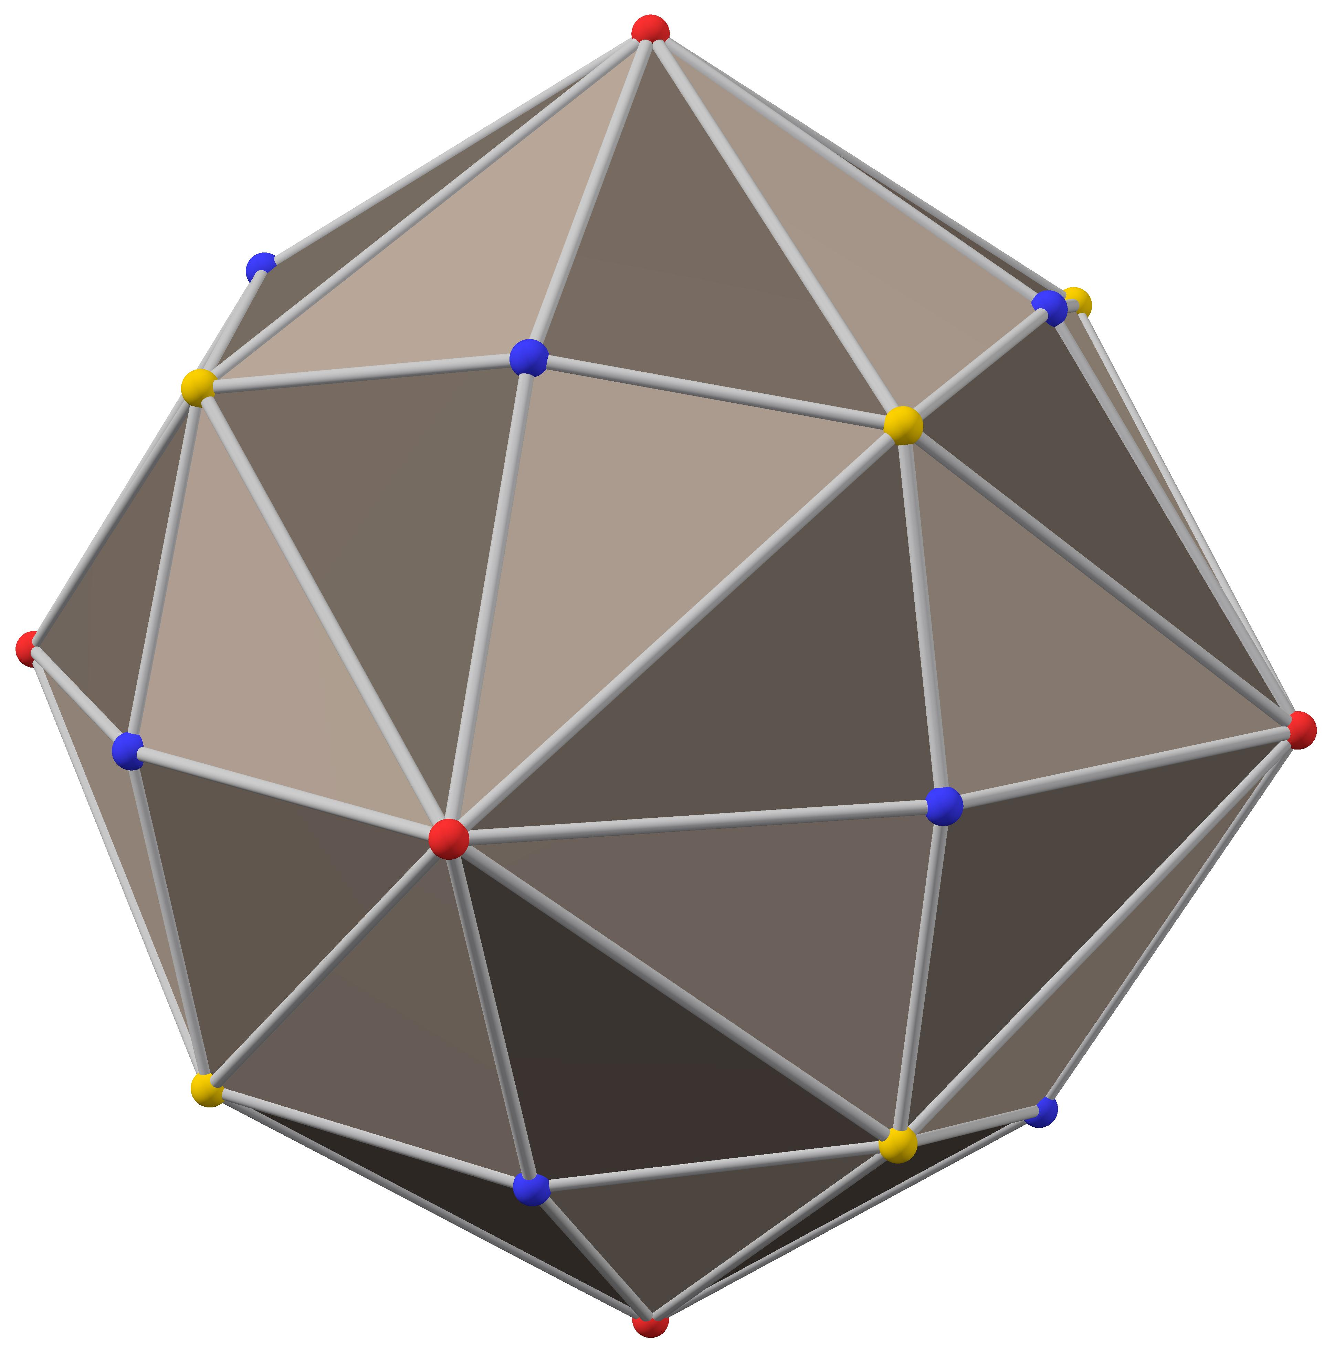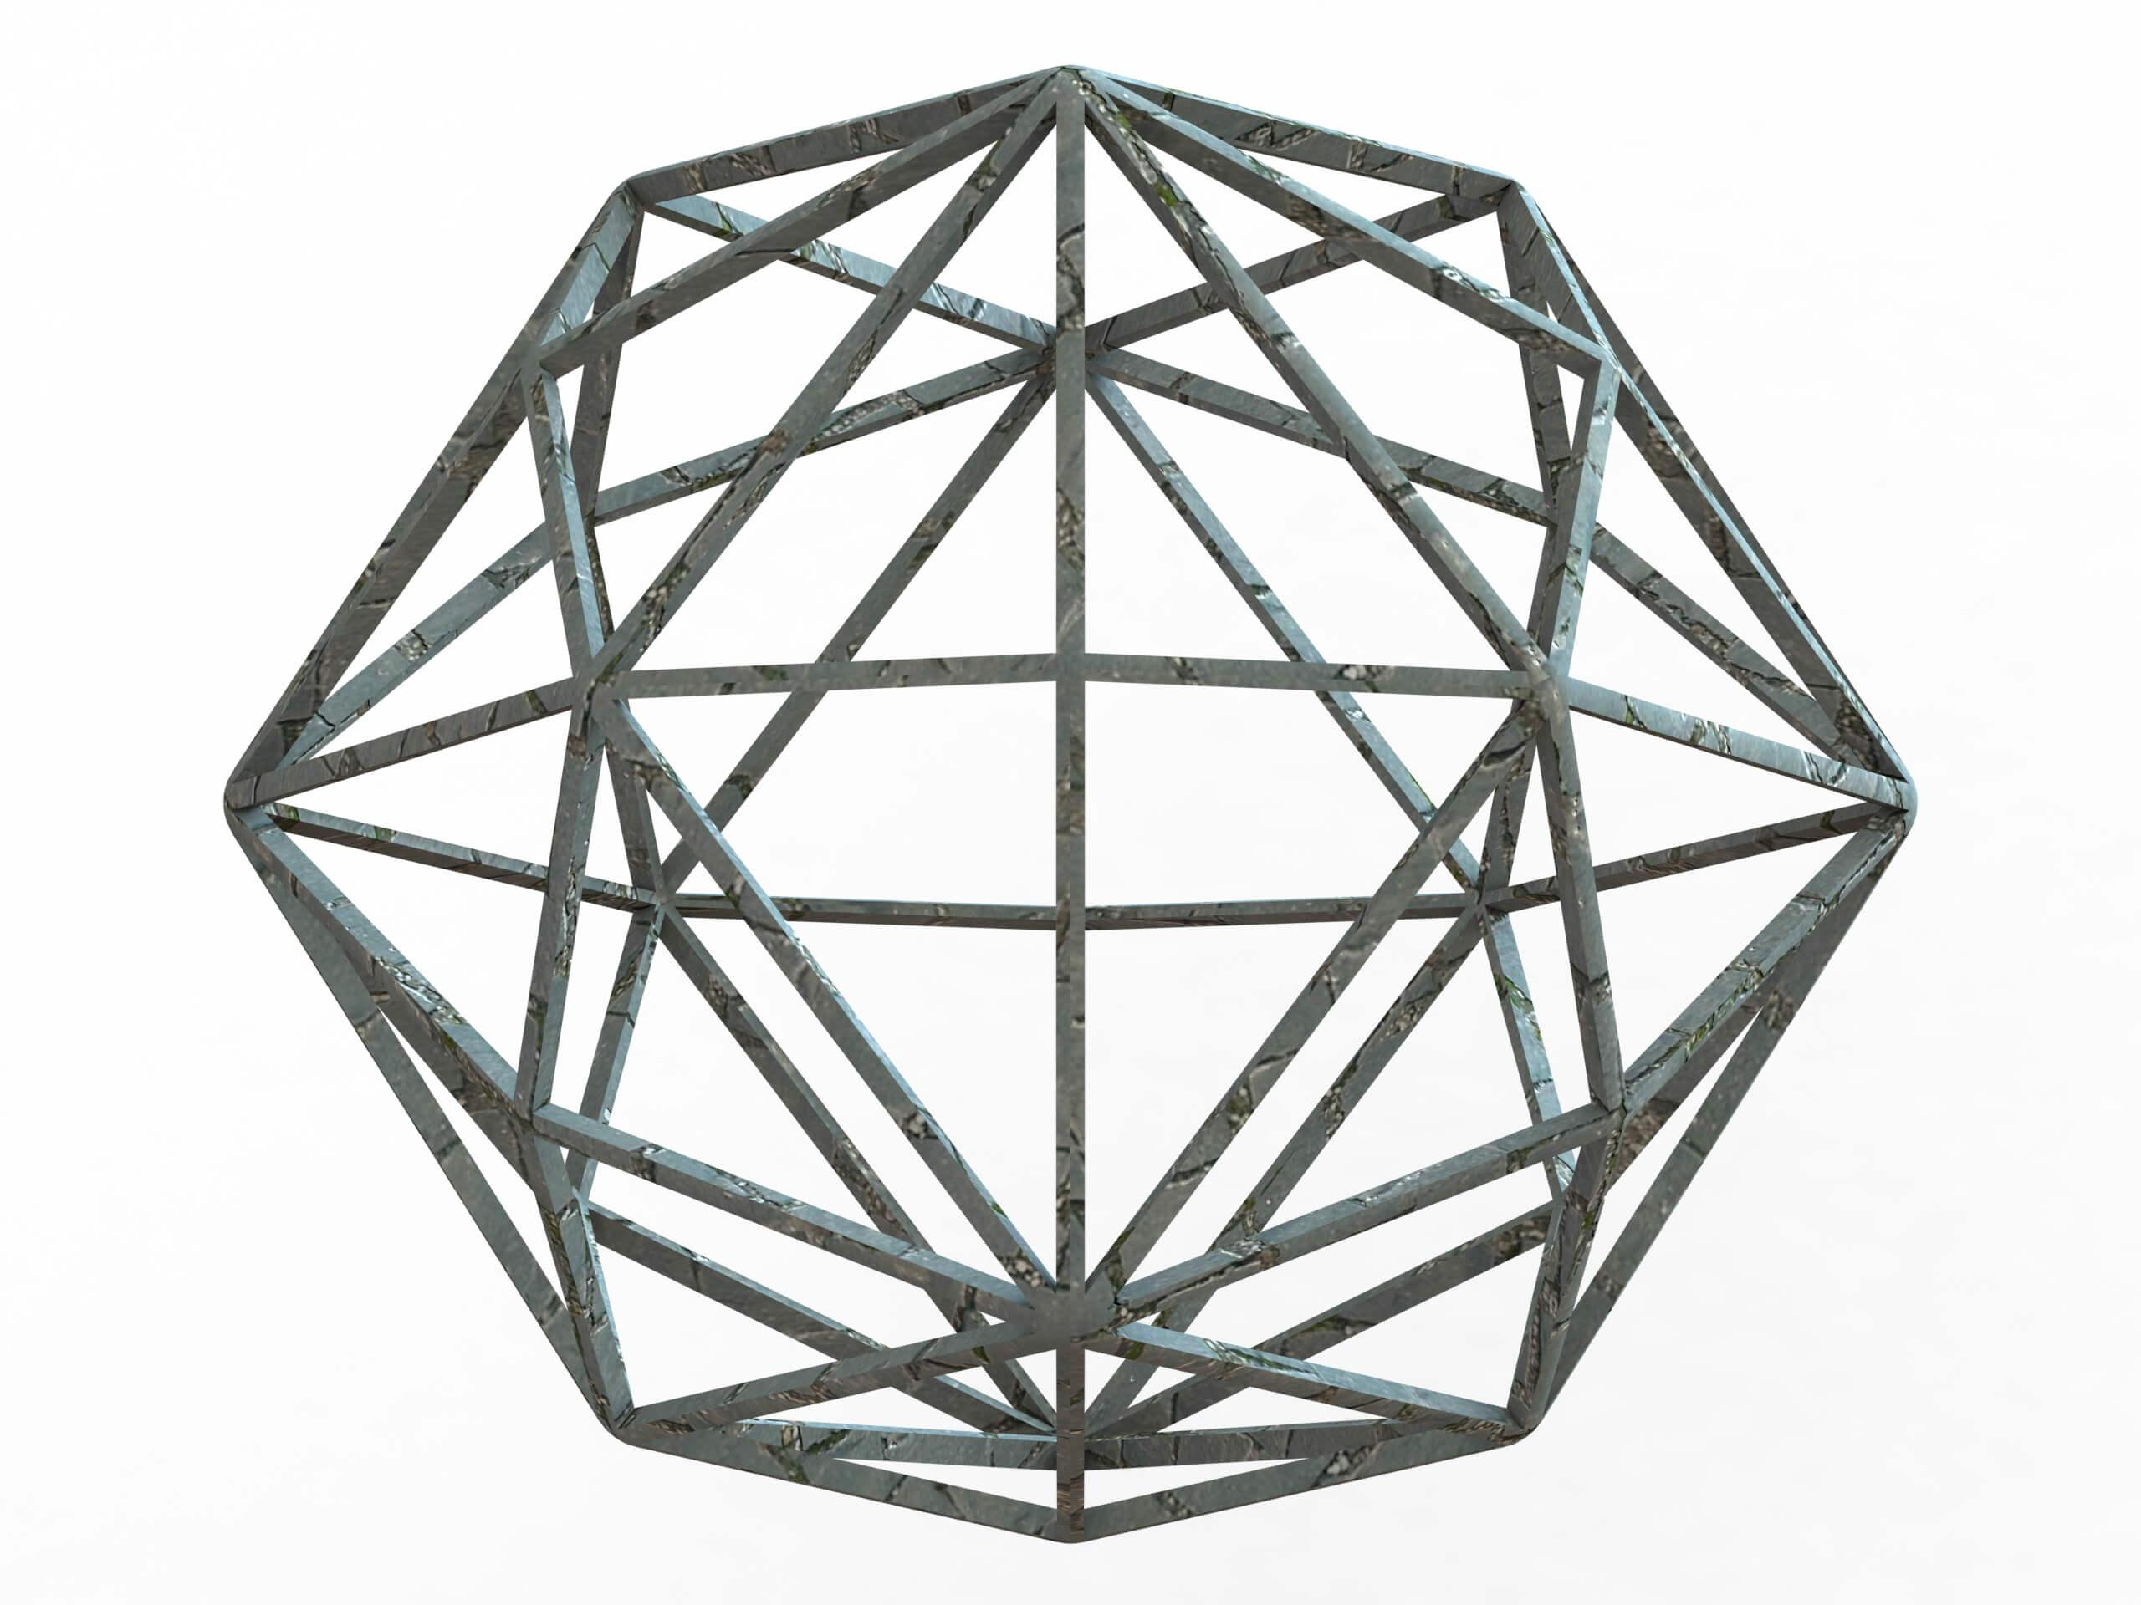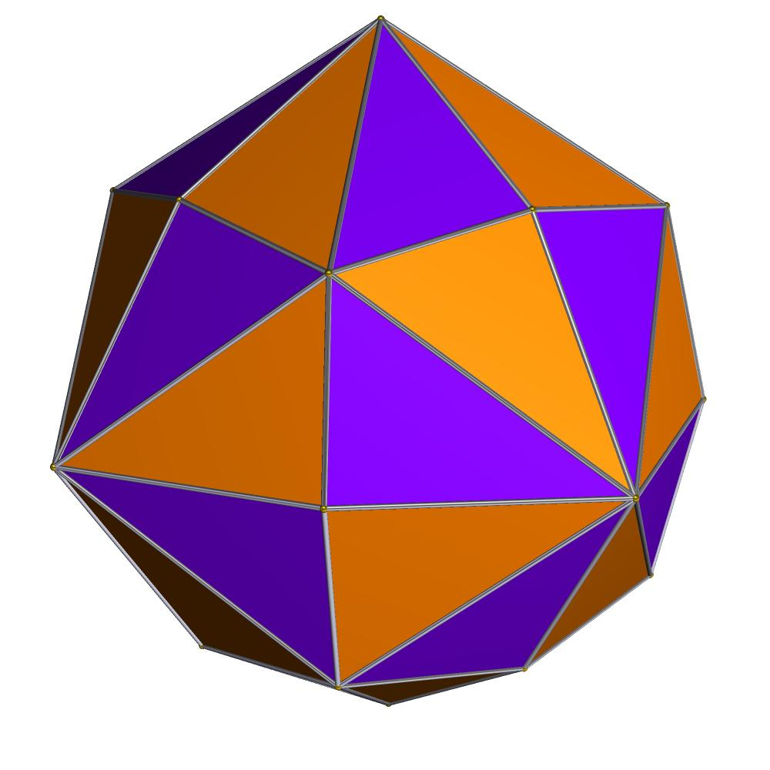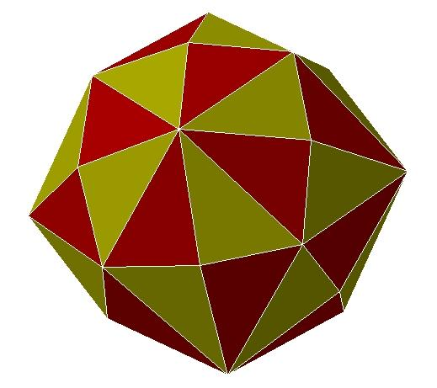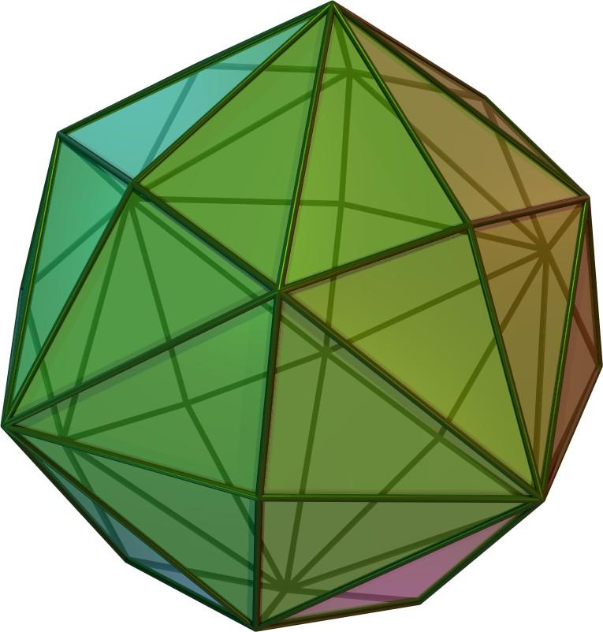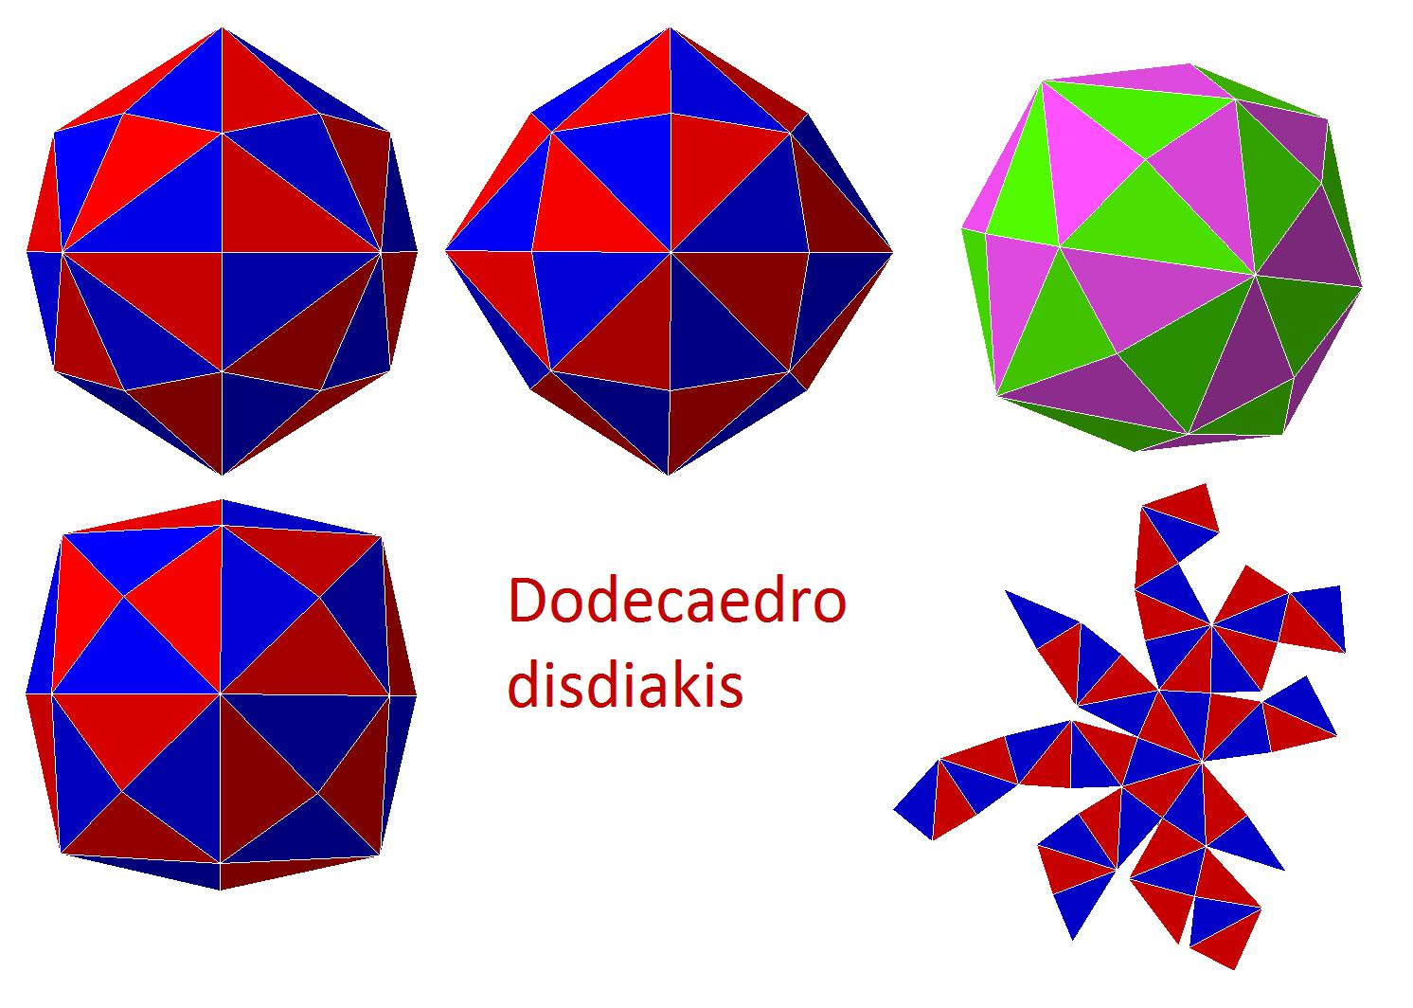

Geometric Structure
# Source: AI Source: Provided by: [Data Path: Persons Table -> ID Column: 1, Name_En Column: Motasem Essam] -> From: [ChatGPT] on [7/25/2026]
- It is a convex polyhedron.
- It has 48 congruent scalene triangular faces.
- Its 48 faces are arranged around 26 vertices.
- It has three different edge lengths.
- It has three different vertex configurations.
- It has full octahedral symmetry.
The solid is face-transitive: every face can be mapped onto any other face by a symmetry of the polyhedron.

Face Structure
# Source: AI Source: Provided by: [Data Path: Persons Table -> ID Column: 1, Name_En Column: Motasem Essam] -> From: [ChatGPT] on [7/25/2026]
The Disdyakis Dodecahedron has 48 congruent scalene triangles.
A scalene triangle has three sides of different lengths and three different interior angles.
Unlike the Triakis Tetrahedron and Tetrakis Hexahedron, its triangular faces are not isosceles triangles. All three side lengths are different.

Edge Structure
# Source: AI Source: Provided by: [Data Path: Persons Table -> ID Column: 1, Name_En Column: Motasem Essam] -> From: [ChatGPT] on [7/25/2026]
The solid has 72 edges, divided into three groups:
- 24 short edges.
- 24 medium edges.
- 24 long edges.
The three edge lengths are different, but each group contains 24 edges.
For a standard model whose dual Great Rhombicuboctahedron has unit edge length, the edge lengths are approximately:
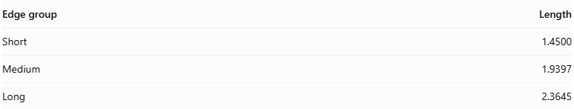
Edge group | Length
Short | 1.4500
Medium | 1.9397
Long | 2.3645

Vertex Structure
# Source: AI Source: Provided by: [Data Path: Persons Table -> ID Column: 1, Name_En Column: Motasem Essam] -> From: [ChatGPT] on [7/25/2026]
The Disdyakis Dodecahedron has 26 vertices, divided into three groups:
- 12 vertices of degree 4: Four triangular faces meet at each vertex.
- 8 vertices of degree 6: Six triangular faces meet at each vertex.
- 6 vertices of degree 8: Eight triangular faces meet at each vertex.
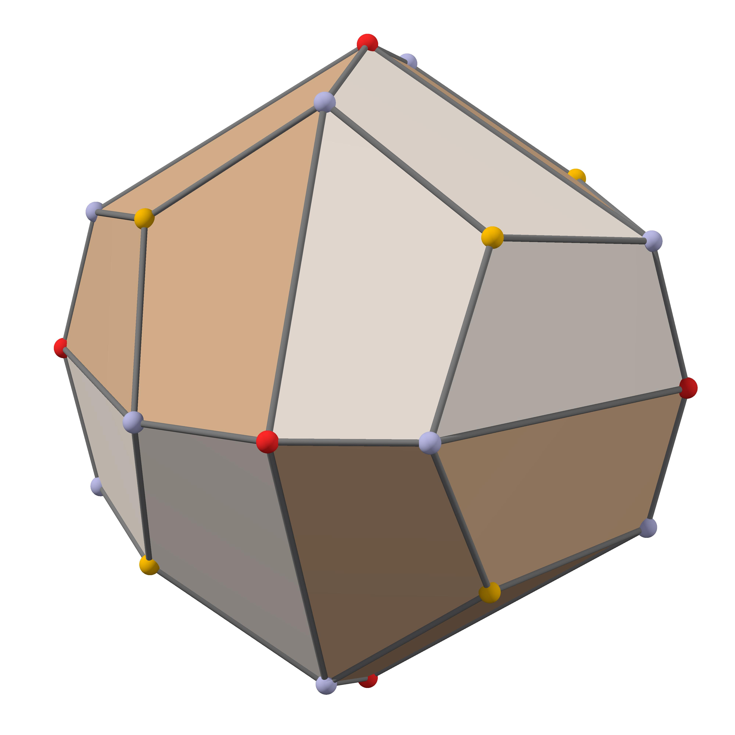
These three vertex groups correspond to the different types of faces of its dual Great Rhombicuboctahedron.

Mathematical Properties
# Source: AI Source: Provided by: [Data Path: Persons Table -> ID Column: 1, Name_En Column: Motasem Essam] -> From: [ChatGPT] on [7/25/2026]
48
Faces
72
Edges
26
Vertices
155.08°
Interior dihedral angle (approx.)
Euler's formula
$$V-E+F=2$$
$$26-72+48=2$$
The Disdyakis Dodecahedron satisfies Euler's polyhedron formula.

Face and edge properties
# Source: AI Source: Provided by: [Data Path: Persons Table -> ID Column: 1, Name_En Column: Motasem Essam] -> From: [ChatGPT] on [7/25/2026]
- All 48 faces are congruent scalene triangles.
- There are three different edge lengths.
- Each edge group contains 24 edges.
- The solid is convex and face-transitive.

Symmetry
# Source: AI Source: Provided by: [Data Path: Persons Table -> ID Column: 1, Name_En Column: Motasem Essam] -> From: [ChatGPT] on [7/25/2026]
The Disdyakis Dodecahedron has full octahedral symmetry, represented by:
$$O_{h}$$
Its symmetry includes:
- Four-fold rotational axes.
- Three-fold rotational axes.
- Two-fold rotational axes.
- Reflection planes.
- Central inversion symmetry.
It is not vertex-transitive because its vertices have three different configurations.

Surface Area and Volume
# Source: AI Source: Provided by: [Data Path: Persons Table -> ID Column: 1, Name_En Column: Motasem Essam] -> From: [ChatGPT] on [7/25/2026]
There is no single surface-area or volume value without specifying the size of the solid.

Surface area
# Source: AI Source: Provided by: [Data Path: Persons Table -> ID Column: 1, Name_En Column: Motasem Essam] -> From: [ChatGPT] on [7/25/2026]
Since all 48 faces are congruent:
$$SA=48A_{f}$$
For a scalene triangular face, using its side lengths $a,b,c$, Heron's formula gives:
$$A_{f}=\sqrt{p(p-a)(p-b)(p-c)}$$
where:
$$p=\frac{a+b+c}{2}$$
Therefore:
$$\boxed{SA=48\sqrt{p(p-a)(p-b)(p-c)}}$$

Volume
# Source: AI Source: Provided by: [Data Path: Persons Table -> ID Column: 1, Name_En Column: Motasem Essam] -> From: [ChatGPT] on [7/25/2026]
For a standard Disdyakis Dodecahedron whose dual Great Rhombicuboctahedron has unit edge length:
$$V=\frac{144(1+\sqrt{2})}{7}$$
$$\boxed{V≈49.6638}$$
The volume changes with the cube of the scale factor.

Relationship to Other Solids

Dual: Great Rhombicuboctahedron
# Source: AI Source: Provided by: [Data Path: Persons Table -> ID Column: 1, Name_En Column: Motasem Essam] -> From: [ChatGPT] on [7/25/2026]
Disdyakis Dodecahedron
Catalan solid
<icon name="arrow-left-right" size="xl"/>
Duality
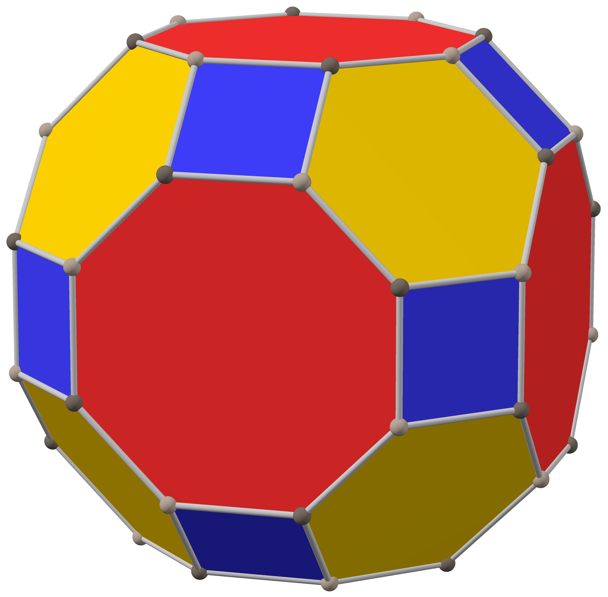
Great Rhombicuboctahedron
Archimedean solid
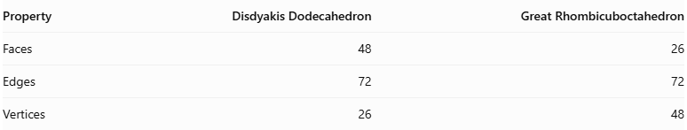
Property | Disdyakis Dodecahedron | Great Rhombicuboctahedron
Faces | 48 | 26
Edges | 72 | 72
Vertices | 26 | 48
In polyhedral duality:
- Each face of the Disdyakis Dodecahedron corresponds to a vertex of the Great Rhombicuboctahedron.
- Each vertex of the Disdyakis Dodecahedron corresponds to a face of the Great Rhombicuboctahedron.
- Their edges correspond to each other.

Constructing a Disdyakis Dodecahedron

Geometric Instruments Used
# Source: AI Source: Provided by: [Data Path: Persons Table -> ID Column: 1, Name_En Column: Motasem Essam] -> From: [ChatGPT] on [7/25/2026]
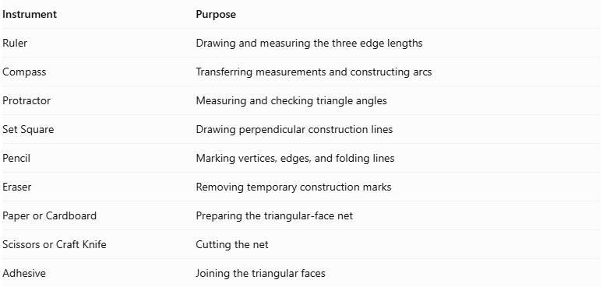
Instrument | Purpose
Ruler | Drawing and measuring the three edge lengths
Compass | Transferring measurements and constructing arcs
Protractor | Measuring and checking triangle angles
Set Square | Drawing perpendicular construction lines
Pencil | Marking vertices, edges, and folding lines
Eraser | Removing temporary construction marks
Paper or Cardboard | Preparing the triangular-face net
Scissors or Craft Knife | Cutting the net
Adhesive | Joining the triangular faces

Instrument-Based Construction Procedures

Method 1: Construction Using a Triangular Net
# Source: AI Source: Provided by: [Data Path: Persons Table -> ID Column: 1, Name_En Column: Motasem Essam] -> From: [ChatGPT] on [7/25/2026]
Step 1: Determine the Three Edge Lengths
- Select a common scale for the model.
- Establish three different edge lengths: short, medium, and long.
- Use a ruler and compass to transfer the measurements accurately.
For the standard Disdyakis Dodecahedron, the edge-length ratio is:
$$\sqrt{22-12\sqrt{2}}:3:2\sqrt{9-4\sqrt{2}}$$
Approximately:
$$0.745:1:1.219$$
Step 2: Construct the First Scalene Triangle
- Draw the longest side using a ruler.
- Set the compass to the medium edge length and draw an arc from one endpoint.
- Set the compass to the short edge length and draw another arc from the opposite endpoint.
- Mark the intersection of the two arcs.
- Connect the intersection to both endpoints.
This produces one scalene triangular face.
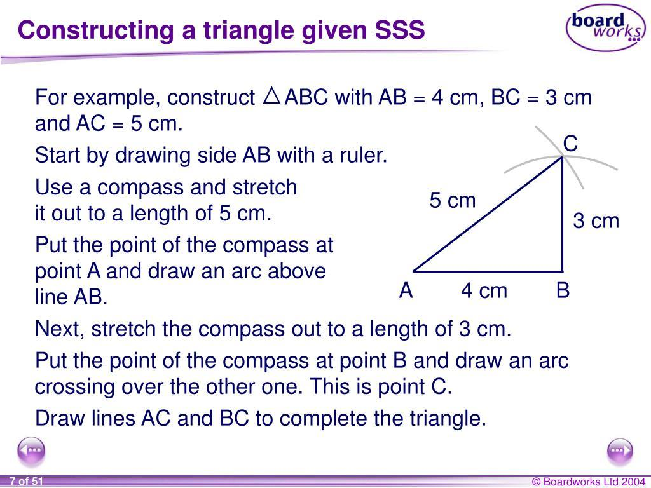
Step 3: Verify the Triangle Dimensions
- Measure all three sides.
- Confirm that the sides have the required short, medium, and long lengths.
- Check that the triangle is not isosceles or equilateral.
- Use the same dimensions for all remaining faces.
Step 4: Construct the Remaining Triangular Faces
- Construct 47 additional triangles.
- Maintain the same three side lengths and corresponding angles.
- Ensure that all 48 triangles are congruent.
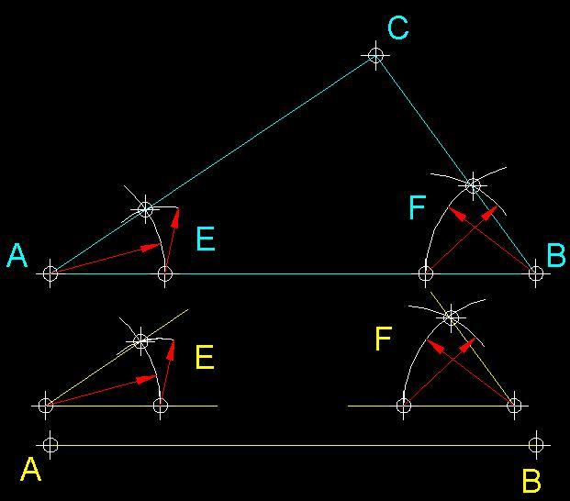
Step 5: Arrange the Triangular Faces
- Arrange the 48 triangles according to the Disdyakis Dodecahedron net.
- Follow the correct edge-to-edge adjacency.
- Ensure that the arrangement produces the required 26 vertices.
- Add joining tabs along selected outer edges.
Step 6: Cut Out the Net
- Cut around the external boundary.
- Preserve all joining tabs.
- Avoid cutting the internal folding lines.
Step 7: Fold the Triangular Faces
- Fold along the shared edges.
- Raise the triangular faces gradually.
- Bring the corresponding edges together.
- Maintain the correct orientation of the short, medium, and long edges.
Step 8: Join the Faces
- Apply adhesive to the joining tabs.
- Connect the corresponding edges.
- Allow the structure to hold its three-dimensional shape.
Step 9: Complete the Solid
Verify the finished model:
- 48 triangular faces.
- 72 edges.
- 26 vertices.
- 24 short edges.
- 24 medium edges.
- 24 long edges.
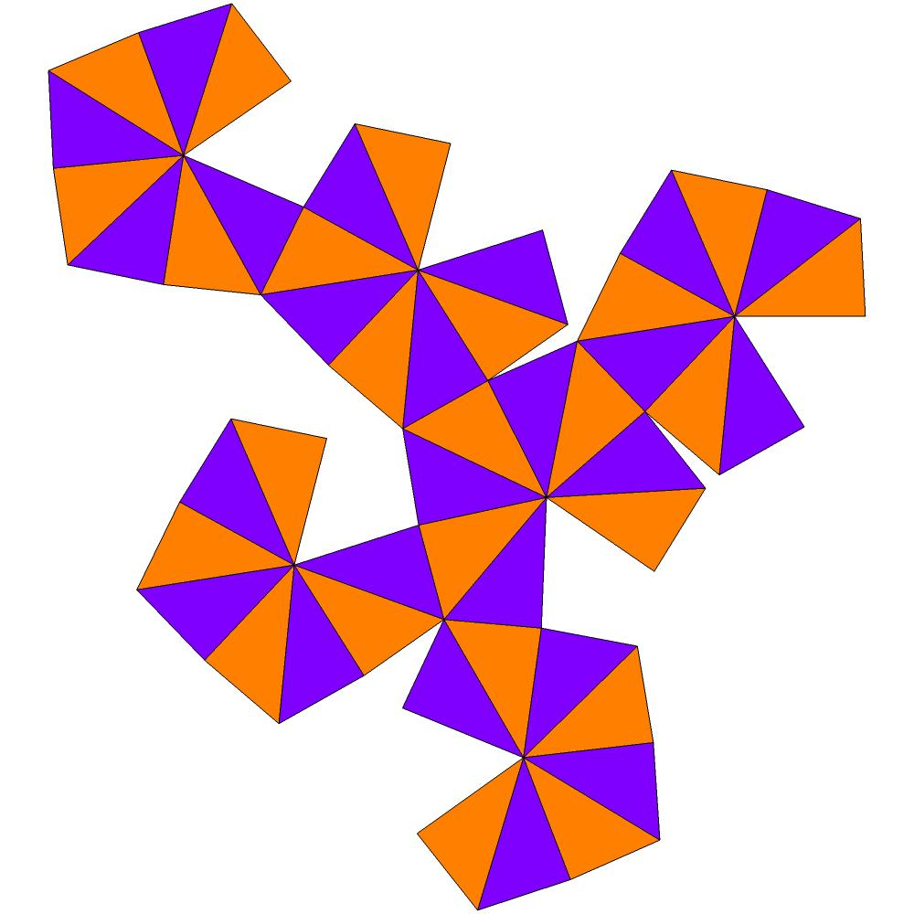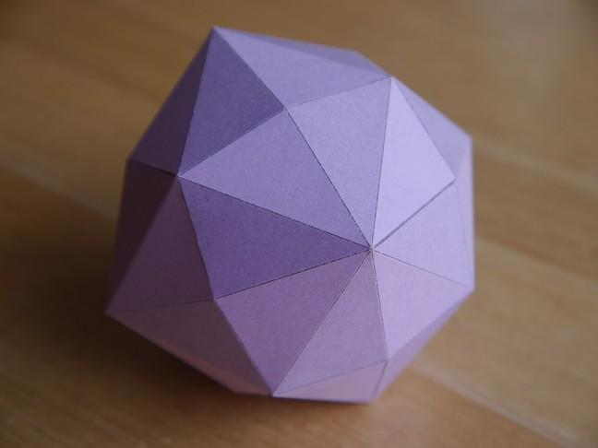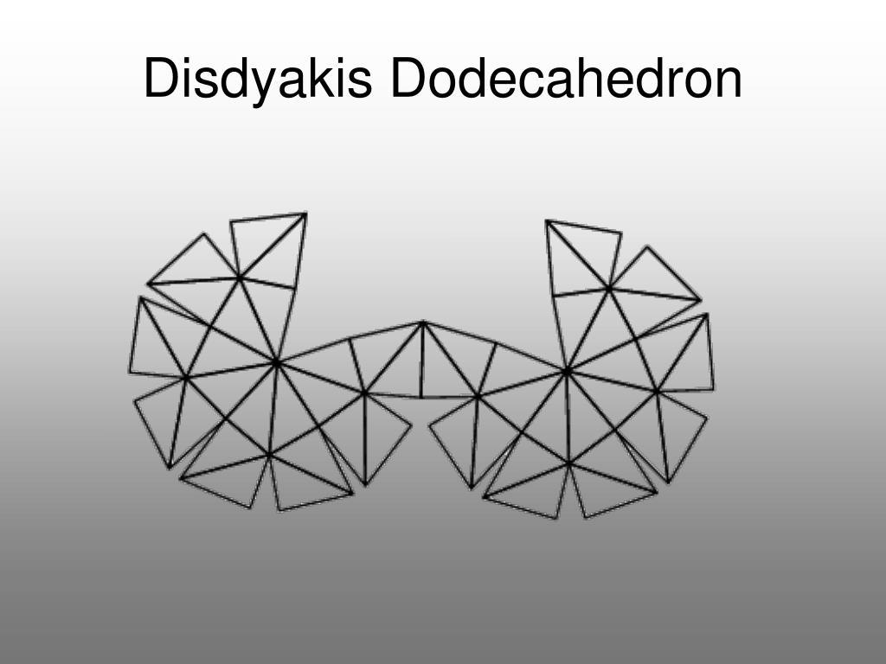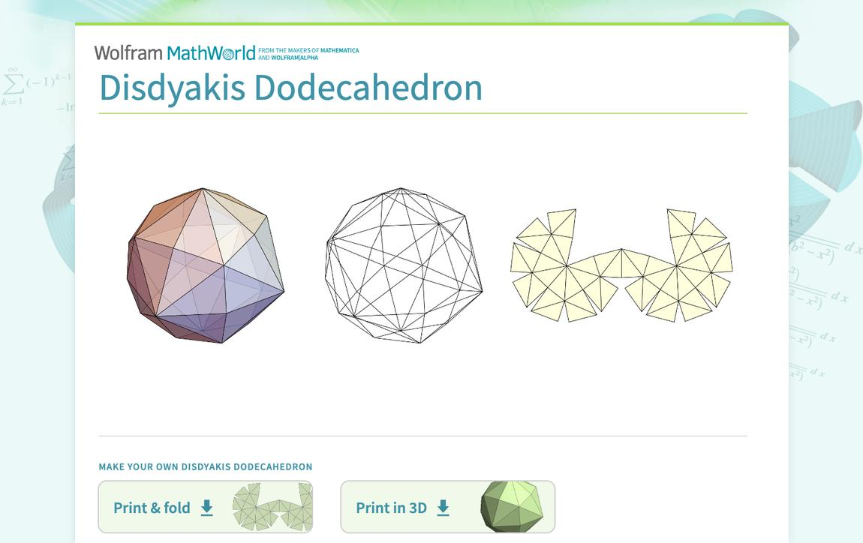

Method 2: Construction Using the Dual of a Great Rhombicuboctahedron
# Source: AI Source: Provided by: [Data Path: Persons Table -> ID Column: 1, Name_En Column: Motasem Essam] -> From: [ChatGPT] on [7/25/2026]
This method uses the dual relationship between the two polyhedra.
Step 1: Construct the Great Rhombicuboctahedron
- Prepare a reference model containing 12 squares, 8 hexagons, and 6 octagons.
- Verify its 48 vertices and 72 edges.
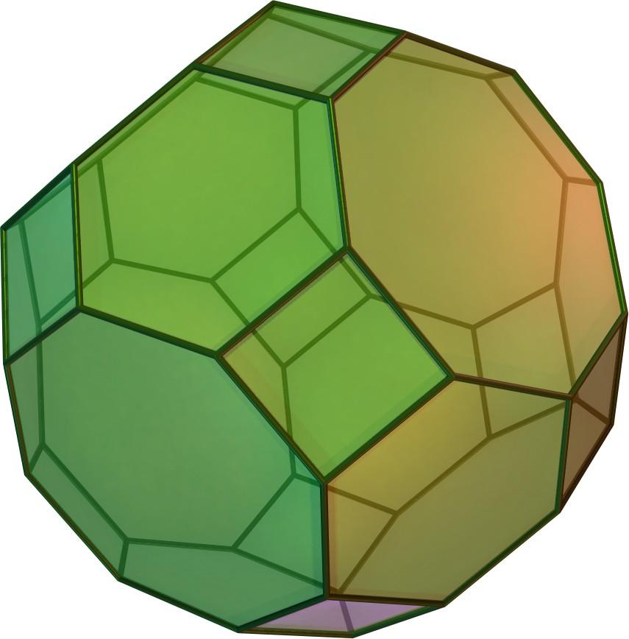
Step 2: Identify the Face Centers
- Mark the center of each square, hexagon, and octagon.
- Identify the perpendicular direction from the center of the solid to each face.
- Use these face-normal directions to establish the dual vertices.
Step 3: Establish the Dual Vertices
- Construct a corresponding dual vertex for each of the 26 original faces.
- Position the dual vertices according to the polar-dual construction.
- Maintain the required symmetry and proportions.
Step 4: Connect Adjacent Face Centers
- Identify the original polyhedron's vertices.
- For every original vertex, connect the dual vertices belonging to the faces meeting there.
- Each original vertex produces one triangular face in the dual.
Step 5: Complete the Dual Structure
- Continue until all 48 triangular faces are formed.
- Verify that the resulting solid has 26 vertices and 72 edges.
- Check the three edge-length classes.
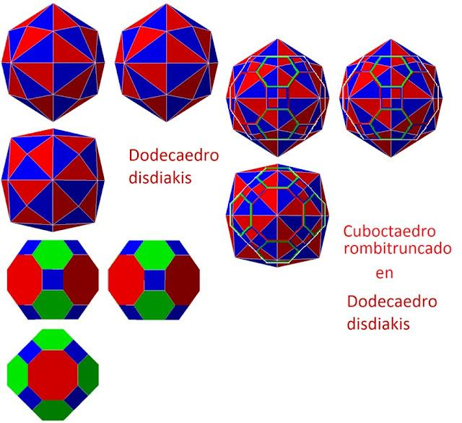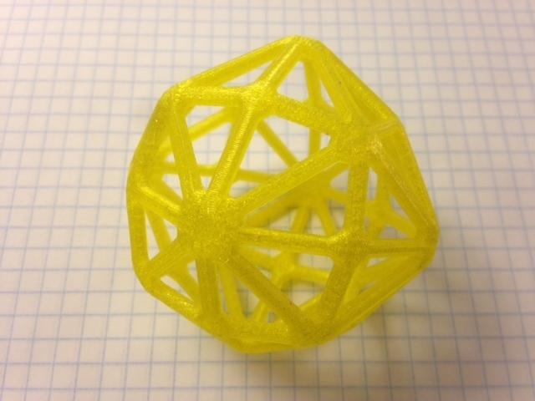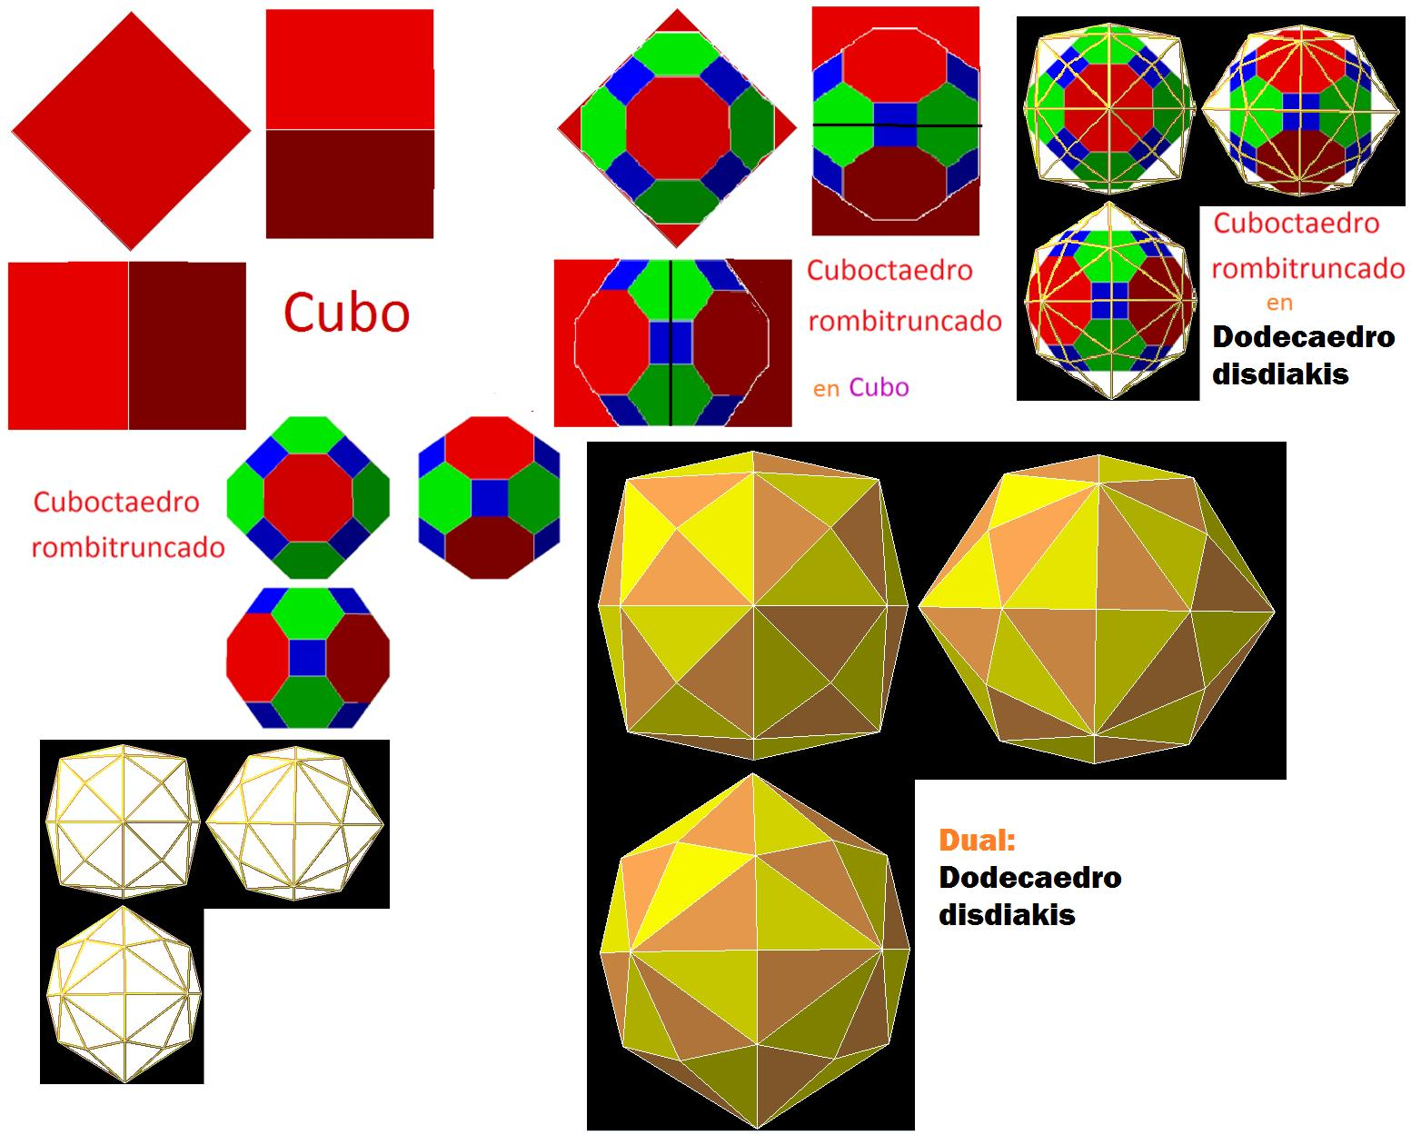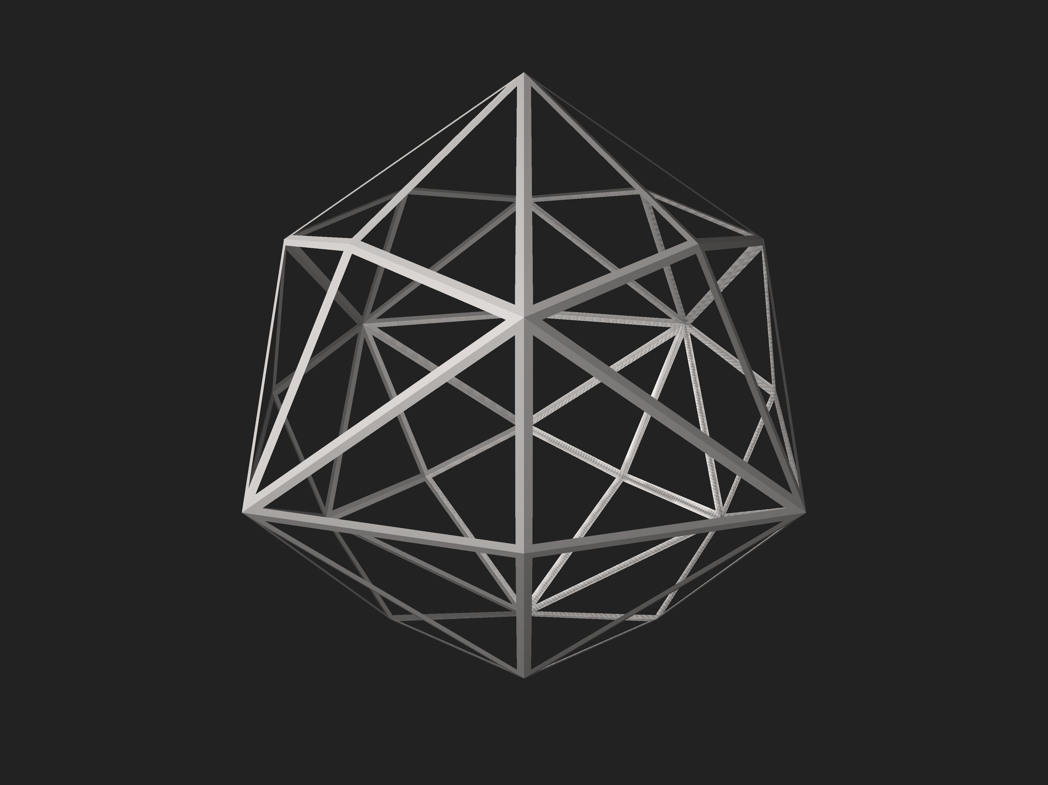
Important: Connecting ordinary face centroids without the correct dual scaling does not necessarily produce the standard Disdyakis Dodecahedron. The face-normal and polar-dual construction must preserve its correct proportions.

Key Points
# Source: AI Source: Provided by: [Data Path: Persons Table -> ID Column: 1, Name_En Column: Motasem Essam] -> From: [ChatGPT] on [7/25/2026]
- The Disdyakis Dodecahedron is a Catalan solid.
- It is the dual of the Great Rhombicuboctahedron.
- It has 48 congruent scalene triangular faces.
- It has 72 edges and 26 vertices.
- Its edges consist of 24 short, 24 medium, and 24 long edges.
- Its vertices have three configurations: degree 4, degree 6, and degree 8.
- It has full octahedral symmetry $O_{h}$.
- It is convex and face-transitive.

Conclusion
# Source: AI Source: Provided by: [Data Path: Persons Table -> ID Column: 1, Name_En Column: Motasem Essam] -> From: [ChatGPT] on [7/25/2026]
The Disdyakis Dodecahedron is an important member of the Catalan solids family. Its 48 congruent scalene triangular faces, three different edge lengths, and three vertex configurations give it a distinctive geometric structure. Its dual relationship with the Great Rhombicuboctahedron makes it an excellent example of polyhedral duality.

